|  |
| --- |
| **Punchh Integration Setup Instructions**  **for**  **Maitre’D** |

Table of Contents

1. Introduction 3

2. Prerequisites 3

3. Setup Using the Punchh Configurator utility 3

3.1. Setup Parameters on the *punchh.cfg* Screen 3

3.1.1. Update the value for the API_Key parameter: 4

3.1.2. Update the LogLevel parameter 4

3.1.3. Update the POS_Type parameter: 4

3.2. Setup Parameters on the *MaitreD.cfg* Screen 4

3.2.1. Update the PathToMaitreD parameter 5

3.2.2. Update the PathToChecks Parameter 5

3.2.3. Update the Port parameter 5

3.2.4. Apply the Changes and Close Punchh Configurator screen 5

3.3. Verify the Punchh Service setup 5

3.3.1. Verify if the Punch Service is Running 5

3.3.2. Verify Existance of the survey.xml file 6

4. Integration of Maitre’D Application with Punchh Service 7

4.1. Start the Maitre’D Back Office: 7

4.2. Configuration on the Server Control screen 7

4.2.1. Discount Manager -> “Communication” option 7

4.2.2. Table Management 8

4.3. Configuration on the Point Of Sale Control screen 8

4.3.1. Navigate to the Point Of Sale Control screen 8

4.3.2. Promotion Setup 8

4.4. Enabling the Survey Printing Functionality 9

4.4.1. Enabling the Survey Mode function 9

4.4.2. Configure Survey Printing 10

5. Setup Verification of the Maitre’D Application 12

5.1. Punchh Locations website 12

5.2. Punchh Configurator 12

5.3. Maitre’D Application 12

5.4. Log Files 12

# Introduction

Punchh **Point of Sales** (**POS**) Integration is done via a proxy web service, which is running on a local network. POS can talk to the service either via HTTP POST calls, direct socket calls, file system, etc. Proxy service forwards calls to the Punchh backend and takes care of logging, heartbeat and queuing the data in case of network outages.

POS Integration is done differently for each POS system, but there is a common component that has to be installed first. That is the **Punchh Integration Service** (PIS).

The required steps for installing the PISon Windows and Lunix are covered by the **Punchh Integration Setup Instructions for Punchh Integration Service** document.

A purpose of this Instruction is to complete the Punchh Integration Setup for the specific POS – **Maitre’D**.

**\*NOTE**: screenshots below maybe different depending on your version of the POS.

# Prerequisites

|  |
| --- |
| **It is a mandatory to do the Punch Integration Setup and Configuration only during the off hours. Otherwise, terminals will be unavailable for business.** |

1. You must complete the Punchh Integration Service setup according to the “**Punchh Integration Setup Instructions for Punchh Integration Service**” successfully.
2. Verify, that you have the valid “**Maitre’D Back Office**” user name and password which gives you edit access to: Interfaces, Screen Designer, Print Designer, Discounts
3. Verify that your MAITRE’D configuration includes the Discount Manager license Add-on:

* Navigate to Maitre’D Application -> Server Control -> View -> Options
* Verify that the **Discount Manager** configuration option is present in the list on the Options applet

# Setup Using the Punchh Configurator utility

Launch the provided **Punchh Configurator** utility:

|  |
| --- |
| "C:\Program Files (x86)\Punchh\Bin\PunchhConfigurator.exe" |

The Punchh Configurator screen should pop up, and by default, you should be navigated to the **punchh.cfg** screen.

## Setup Parameters on the *punchh.cfg* Screen

Update the following parameters shown on the screen below with appropriate data using drop-down menu options or direct typing.

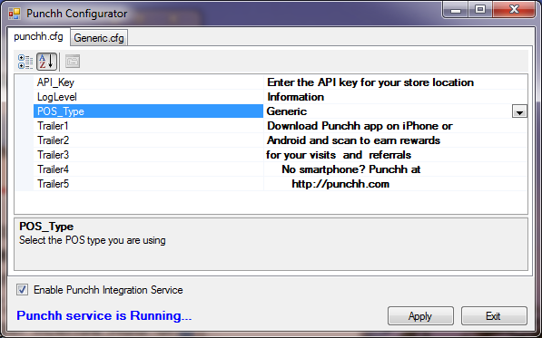

### Update the value for the API_Key parameter:

* Navigate to the Punchh Locations website (<https://punchh.com/locations>), log in, and find the API Key **specific for your location**
* Make a copy of the API Key that you just found
* On the on the **punchh.cfg** screen, select the **API_Key** parameter
* Enter your API Key into the “**Enter the API key for your store location**” field

### Update the LogLevel parameter

1. Introduction

The logging level can be customized. The following logging levels are available:

**\*NOTE:** Each next level includes all the levels above it.

The logging level can be customized. The following logging levels are available:

1. **None** – logging is completely suppressed
2. **System** – logging service startup and shutdown messages
3. **Errors** – logging errors only
4. **Warning** - logging warnings and errors
5. **Information** - logging information, warnings, and errors
6. **Request** – logging HTTP Requests Sent
7. **Response** – logging HTTP Responses Received
8. Customizing the logging level

To customize the logging level, please do the following:

* Select the **LogLevel** item, navigate to the LogLevel field, and open the drop-down list.
* Select an appropriate item from the list per the log level options explained above.

### Update the POS_Type parameter:

* Select the **POS_Type** item, navigate to the **Generic** field, and open the drop-down list.
* Select the **MaitreD** item from the list.
* Verify, that the **Generic.cfg** tab is automatically renamed to the **MaitreD.cfg** name per your selection in the step above.
* Hit the **Apply** button

## Setup Parameters on the *MaitreD.cfg* Screen

1. On the Punchh Configurator screen, select the **MaitreD.cfg** tab
2. On the **MaitreD.cfg** screen, update the following parameters shown on the screen below with appropriate data using drop-down menu options or direct typing.

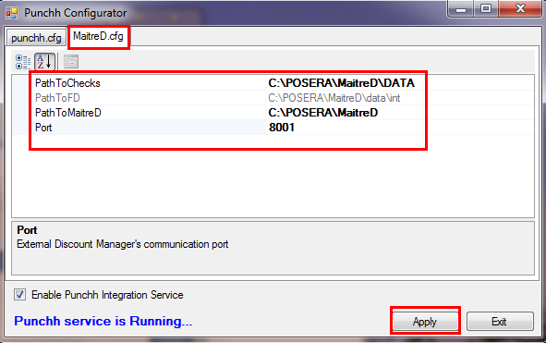

### Update the PathToMaitreD parameter

Verify & Update a navigation path in the **PathToMaitreD** parameter.

The value for the **PathToMaitreD** parameter must be pointed into the actual directory where the MaitreD software is installed. By default, it comes with the “**C:\POSERA\MaitreD**” value. If you have installed the MaitrD software in any different location (for instance, in the “**C:\Program Files\MaitreD”** location), then you need to update the value with a path to your actual location (for instance, **“C:\Program Files\MaitreD”)**

### Update the PathToChecks Parameter

Verify where the MaitreD software is installed and edit this parameter according to the actual location, if needed.

For instance: **C:\POSERA\MaitreD\DATA\Punchh**

### Update the Port parameter

Please leave the default value such as “**8001**” as it is.

### Apply the Changes and Close Punchh Configurator screen

On the **Punchh Configurator** screen, hit the **Apply** button. This step will restart the Punchh service and you will see the following changes on the Punchh Configurator screen:

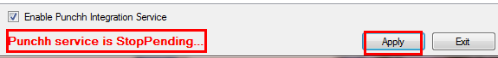

Hit the **Exit** button and it will close the **Punchh Configurator** screen.

## Verify the Punchh Service setup

### Verify if the Punch Service is Running

Verify that the Punch Configurator did start the Punch Service automatically:

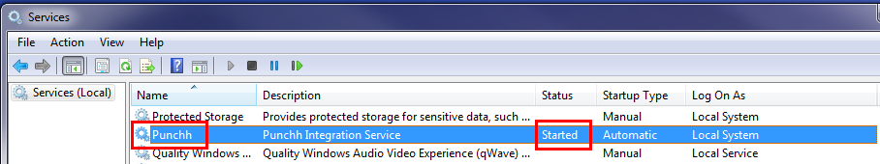

**\*NOTE:** You may want to set the following service recovery options as it is shown below (it is OPTIONAL):

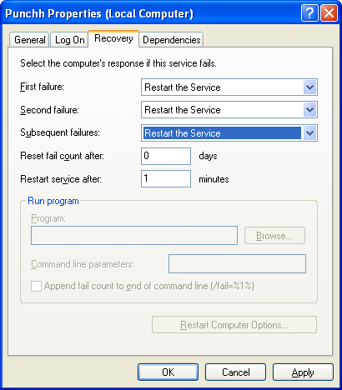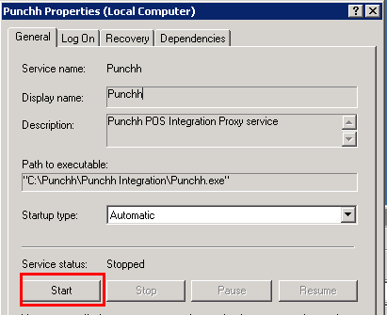

### Verify Existance of the survey.xml file

After applying changes you completed on the **Punchh Configurator** screen, and restarting the Punchh service, the Punchh Service automatically generates the Punchh’s **survey.xml** file and puts it into a specified place such as **C:\POSERA\MaitreD\DATA**.

1. Verify, if the Punchh Service did generate and put the **survey.xml** file into the **C:\POSERA\MaitreD\DATA** folder

For instance, “***C:\POSERA\MaitreD\DATA\Survey.xml”***

1. Verify the latest log file (for instance, in the “**C:\Program Files (x86)\Punchh\Logs**” directory)

If there are no any issues, then the Punchh Service reports this kind of information in the log file for each location shown above:

|  |
| --- |
| **4/25/2014 4:38:05 PM [Information]: Created or updated: C:\POSERA\MaitreD\DATA \survey.xml** |

1. If the Punchh Service finds the **survey.xml** file already existing in this directory, then the Punchh Service does NOT overwrite the existing **survey.xml** file and reports such issues into a log file. For instance,

|  |
| --- |
| **4/25/2014 3:36:47 PM [Error]: File C:\POSERA\MaitreD\DATA\survey.xml doesn't seem to belong to Punchh. Please ensure we don't overwrite 3rd party files** |

In this case, please complete the following steps:

1. Rename or delete the existing **survey.xml** file
2. Restart the Punchh service
3. Make sure, that the Punchh Service did put the **survey.xml** file into the **C:\POSERA\MaitreD\DATA** folder

For instance, “***C:\POSERA\MaitreD\DATA\Survey.xml”***

|  |
| --- |
| **\*NOTE:**   1. The Punchh service has to be restarted manually **every time after you manually edited the config files**.If you have NOT changed any values in the config files, then no need to restart the Punchh service. 2. When you are setting up the Punchh service, the Punchh Configurator restarts the service automatically, as needed. |

# Integration of Maitre’D Application with Punchh Service

## Start the Maitre’D Back Office:

1. Verify an Availability and Connect the Maitre’D Back Office

The Maitre’D Back Office must be setup and being accessible

1. Launch Maitre’D Back Office and enter valid <UserID>/<Password>

For instance, C:\POSERA\MaitreD\PRG\bo.exe /FC:\POSERA\MaitreD\DATA\BO.INI

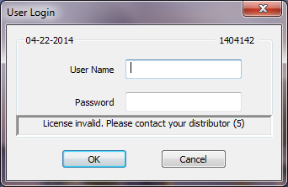 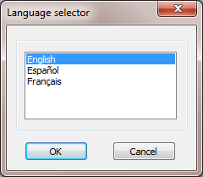 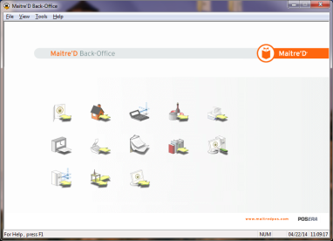

## Configuration on the Server Control screen

Select the **Server Control** hyperlink and then, on the **Server Control** screen select the **View -> Options:**

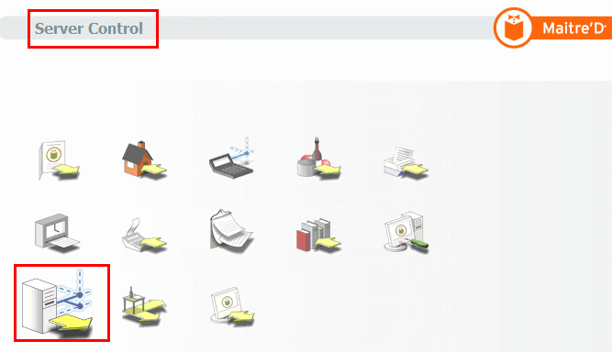 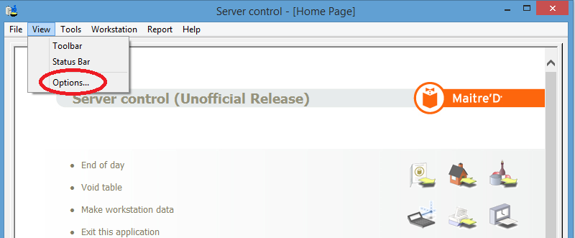

### Discount Manager -> “Communication” option

1. On the Configuration screen -> Application Map, select the **Discount Manager** -> **Communication** option

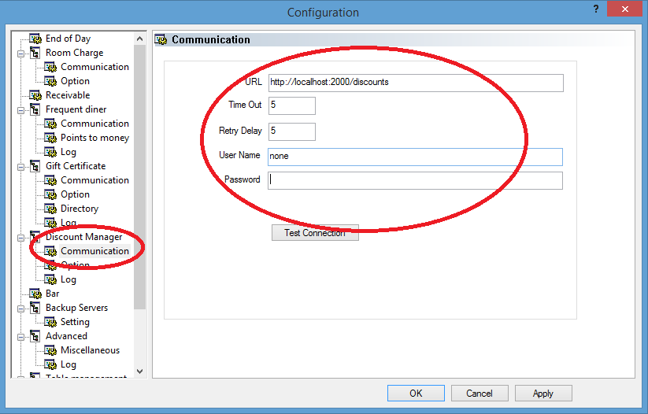

1. Enter the following values:

* Local host URL, like <http://localhost:2000/discounts>
* Time Out: 5
* Retry Delay: 5
* User Name: none
* Password: <leave blank>

1. Select the **Apply** button

### Table Management

1. On the Configuration screen -> Application Map, select the **Table Management** option

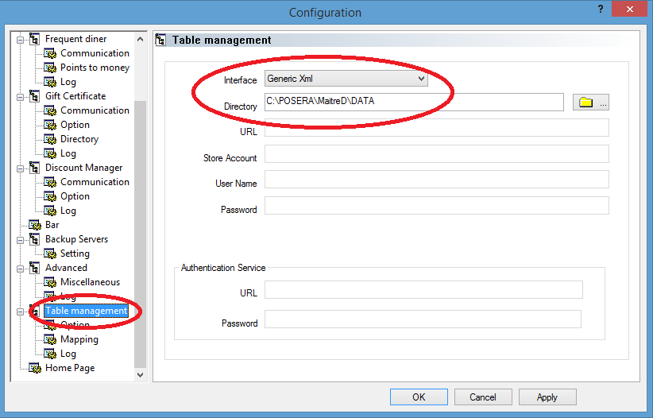

1. Enter the following values:

* Interface: **Generic Xml**
* Directory: <pass to the Data directory> (for instance, **C:\POSERA\MAITRED\DATA**)

1. Select the **Apply** button
2. Close the Configuration screen

## Configuration on the Point Of Sale Control screen

### Navigate to the Point Of Sale Control screen

1. Navigate to the **Main** screen and select the **Point Of Sale Control** hyperlink

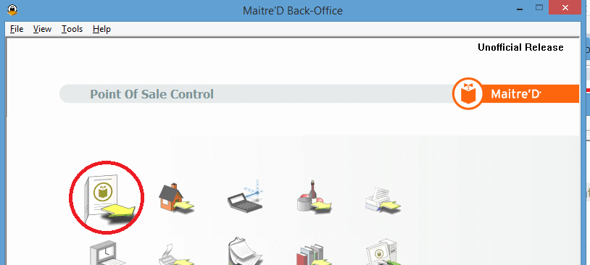

### Promotion Setup

1. On the **Point Of Sale Control** screen, select the **Promotion Setup** hyperlink on the left applet
2. On the **Promotion** screen, select the **Add** button. The new Promotion applet should popup
3. On the new **Promotion** applet, create a new discount named “**Punchh Discount**” and enter the following values as it is shown on the screenshot below:

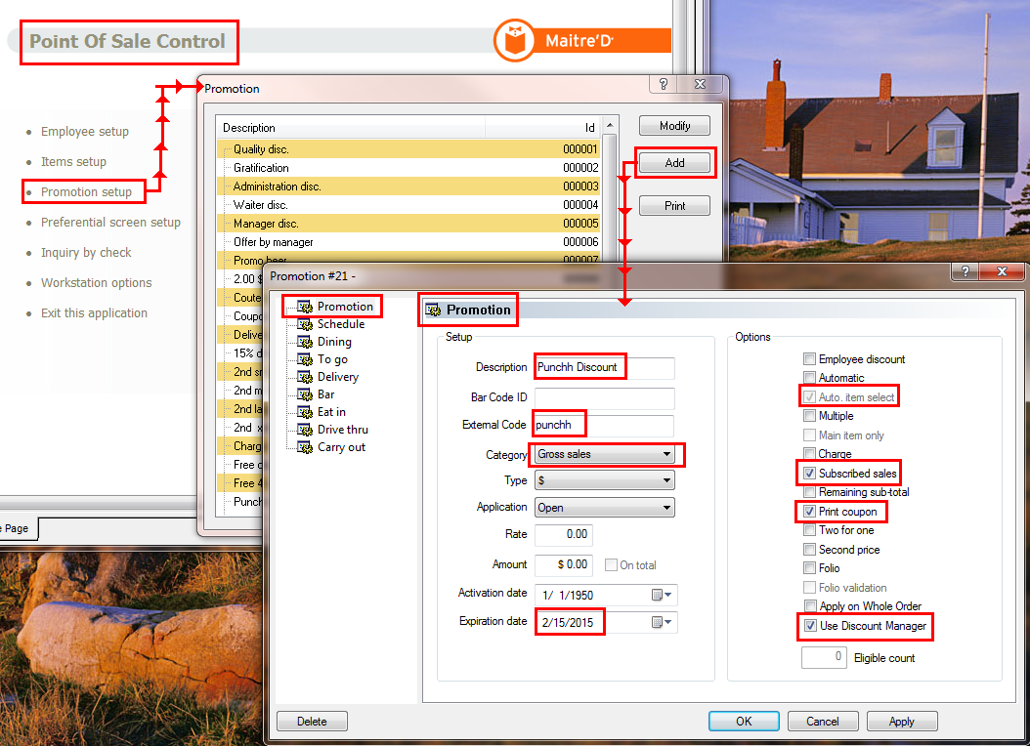

1. Select the **Apply** button
2. Select the **OK** button
3. Select the **Close** button on the **Promotion** screen
4. Close the **Point Of Sale Control** screen

## Enabling the Survey Printing Functionality

### Enabling the Survey Mode function

By default, the Maitre’D can produce the evaluation sheet. To replace the evaluation sheet with the **Survey**, please update the **BO.ini** file:

1. Verify if the BO.INI file exists. For instance, **C:\POSERA\MaitreD\DATA\BO.INI**
2. Update the BO.ini file with adding the “**SurveyMode=True**” parameter to the **Miscellaneous** section

**[Miscellaneous]**

**SurveyMode=True**

1. Save your changes and close the BO.INI file.
2. Stop the **Maitre’D Back-Office** server (for instance, C:\POSERA\MaitreD\PRG\**bosrv.exe**), and close all back-office modules as the following:

* Navigate to the **Server control** screen:



* The **Server control** screen, navigate to the menu ‘**File -> Stop Server**’ and select the “**Stop Server”** menu item

1. Start the Maitre’D Back-Office and enter <UserID>/<Password>

For instance, C:\POSERA\MaitreD\PRG\bo.exe /FC:\POSERA\MaitreD\DATA\BO.INI

1. Navigate to the **Server control** screen
2. Select the **Make Workstation Data** hyperlink on the Menu applet:

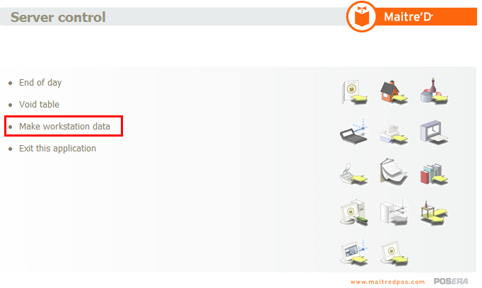

1. Start the Maitre’D Back-Office server (**bosrv.exe**)
2. On the **Server control** screen, navigate to the menu ‘**File -> Start Server**’ and select the **Start Server** menu item
3. Close the **Server control** screen

### Configure Survey Printing

1. Navigate to the **Maitre’D Back-Office** main screen and select the **Point Of Sale Control** hyperlink
2. Navigate to the menu, select the **Menu -> Revenue Center -> Options** menu item. The **Revenue Center Selection** screen should popup:

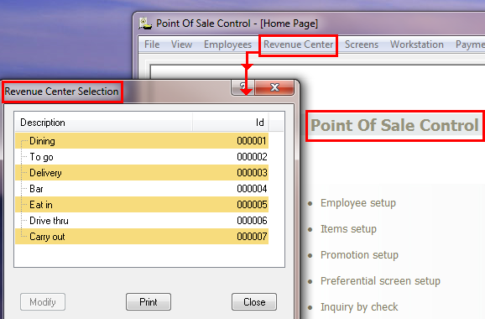

1. On the **Revenue Center Selection** screen, update values for the **Modes** and the **Workstation** parameters for every revenue item available in the list as it is shown below, or update just some of the items as you need. For instance, “**Dining”**:
   * 1. **Modes**

* On the **Revenue Center Selection** screen, double-click on the ***Dining*** revenue item. The “**Configuration by Revenue Center #... – Dining**” screen should popup
* On the “**Configuration by Revenue Center #... – Dining**” screen, navigate to the Menu applet and select the **Modes** item. The **Modes** applet should appear
* On the **Modes** applet, edit every mode and put the **100.00** value into the “**% Customer**” field as it is shown below. It means that the **100% of checks** will have a survey printed.

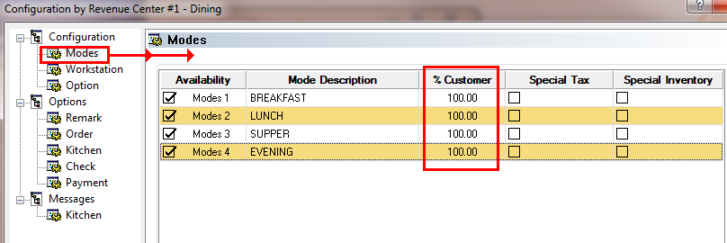

* + 1. **Workstation**

1. On the “**Configuration by Revenue Center #... – Dining**” screen, navigate to the Menu applet and select the **Workstation** item. The **Workstation** applet should appear
2. On the **Workstation** applet, select the ***Normal*** evaluation sheet:

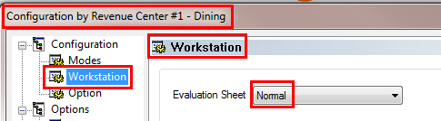

# Setup Verification of the Maitre’D Application

By default, both the Punchh Barcode Printing and the Punchh Receipt Messages functionalities are enabled. To verify the setup, please complete the following steps.

## Punchh Locations website

1. Navigate to the Punchh Locations website: <https://punchh.com/locations>. You should be navigated to the **Businesses** screen
2. Find your POS on the **Businesses** screen. For instance, select **Sample Café**, and you should be navigated into the **Sample Café Dashboard** screen
3. Select the “**Setting**” -> “**Receipts Messages**” item on the Dashboard menu applet.
4. You should be navigated to the “**Recept Messages**” screen.
5. On this screen, navigate to the section associated with your location (for this example, **Test – Maitre’D**)
6. Review the existing message, for instance “**Punchh greets you!”**:

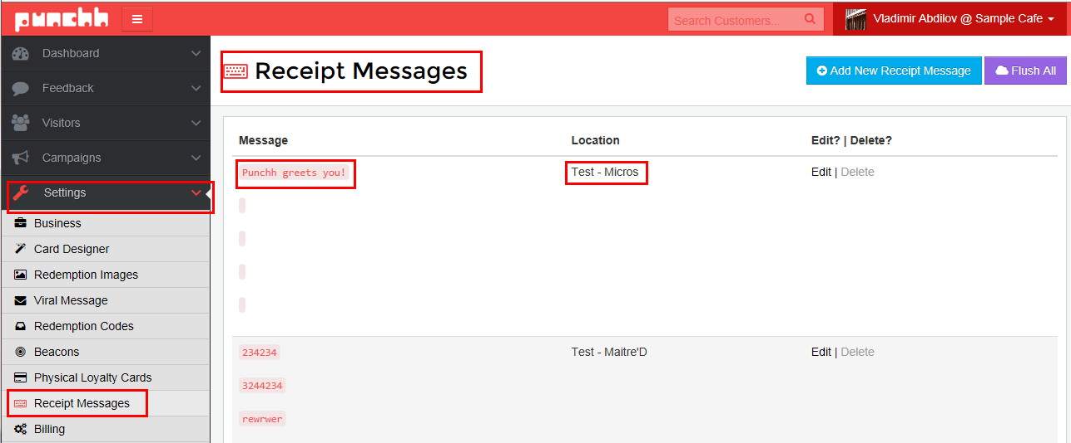 

## Punchh Configurator

* Launch the provided **Punchh Configurator** utility:

|  |
| --- |
| "C:\Program Files (x86)\Punchh\Bin\PunchhConfigurator.exe" |

You should be navigated to the **punchh.cfg** screen.

* At the **punchh.cfg** screen, verify that the values in trailers are the same as it is on the Punchh website above:

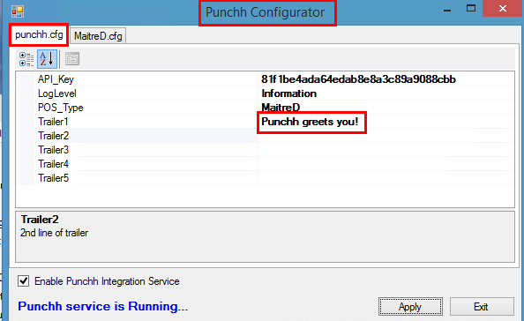

## Maitre’D Application

1. Open the **MAITRE’D** application, create an order, and submit the “**Pay Cash**” payment type.
2. Review the printed receipt:

* the Punchh barcode has to be printed
* the message located below the Punchh barcode, has to be the same as it is specified on the “**Recept Messages**” screen, for instance “**Punchh greets you!”**

## Log Files

Navigate to the Punchh log directory (for instance, “C:\Program Files (x86)\Punchh\Logs”).

Launch the log file, and search for any errors and warnings. Make sure that No any errors and warnings should be reported

|  |
| --- |
| **The Punchh Integration Setup for the POS “MAITRE’D” is complete!** |